**TABLE STRUCTURE**

1. Table Name: admin

Description: To store the admin credential Information.

Primary Key: admin_id

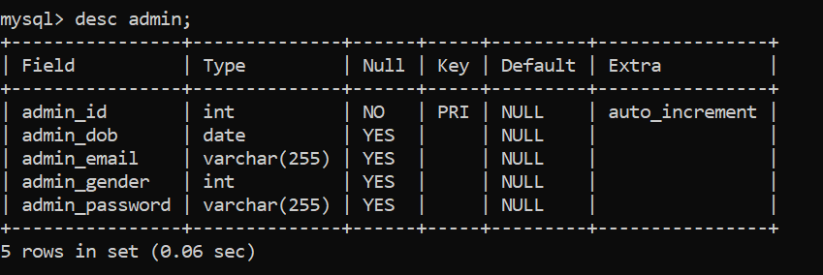

1. Table Name: students

Description: To store the user Personal Information.

Primary Key: student_id

Foreign Key: assigned_mentor_id, student_course_id , student_address_id

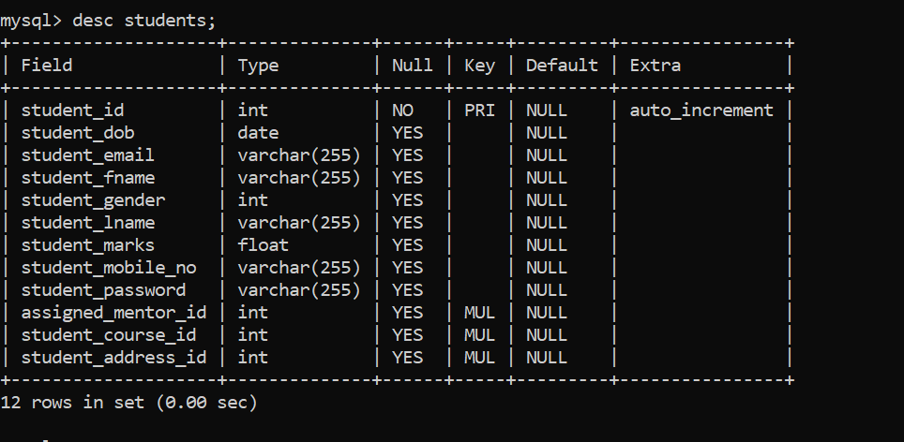

1. Table Name: courses

Description: To store the courses releated Information.

Primary Key: course_id

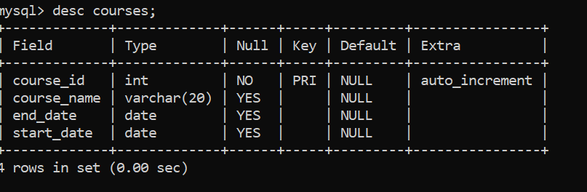

1. Table Name: mentors

Description: To store the Mentors Personal Information.

Primary Key: mentor_id

Foreign Key : mentor_course_id , mentor_address_id

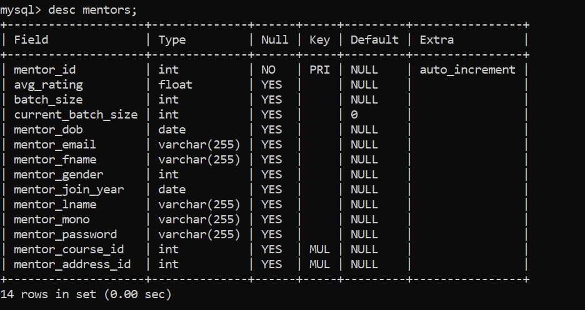

1. Table Name: addresses

Description: To store the address releated Information.

Primary Key: address_id

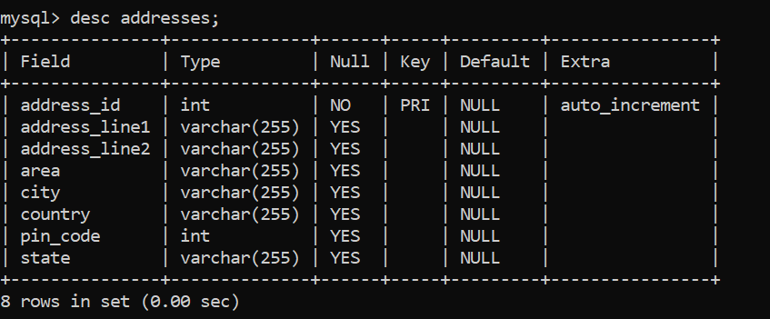

1. Table Name: queries

Description: To store the queries releated Information.

Primary Key: query_id

